

**DEPT. Of Electronic and Engineering**

**SRM IST, Kattankulathur – 603 203**

**Sub Name: PROGRAMMING FOR PROBLEM SOLVING**

|  |  |
| --- | --- |
| **Title** | PARKING SYSTEM |
| **STUDENT NAME** | AYUSH RAJ |
| **Register Numbers** | RA2111004010257 |
| **Date** | 22-02-2022 |

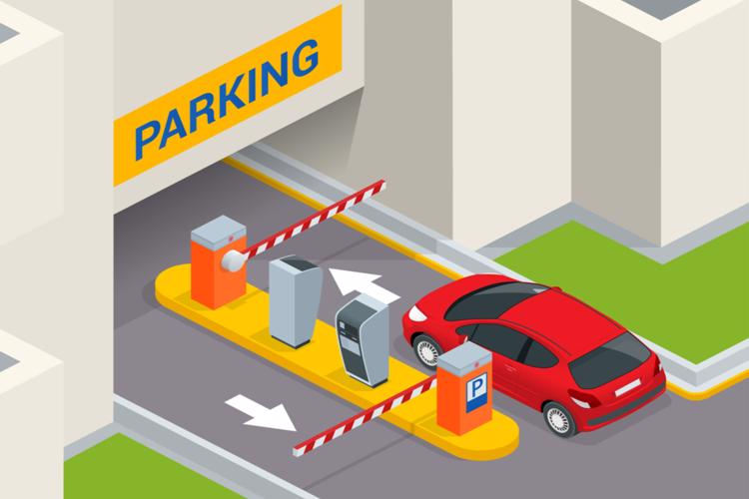

DESCRIPTION OF THE PROJECT:

Mini project "PARKING SYSTEM" is a simple project built in C. This project has the following features: It displays a nicely built menu to have the entry of the vehicles. We can register the number of vehicle by following a simple menu. For example, in the menu we can enter the cars by simply entering the corresponding number and even check the status which displays the number of cars registered and total sum collected. The functions used in the source code are simple and easy to understand: int menu(); void bus(); void car(); void bike_or_cycle(); void delete(); void status();

***ALGORITHM***

**step 1: Start**

**STEP 2: Declare the following functions:**

**menu**

**bus**

**car**

**bike_or_cycle**

**delete**

**status**

**STEP 3: Declare the following global variables**

**Nob**

**Noc**

**Noboc**

**Amt**

**tcount**

**STEP 4: code the following function to get the sense of program**

**STEP 5: Display the following:**

**Fill the function to get the sense of the program.**

**Step 6: Integrate the following function with main function**

**STEP 7: Check and correct the Errors in the program.**

**Step 8: END**

**CODE:**

#include <stdio.h>

#include <conio.h>

#include <stdlib.h>

int menu();

void bus();

void car();

void bike_or_cycle();

void delete();

void status();

int nob=0,noc=0,noboc=0,amt=0,tcount=0;

void main()

{

while(1)

{

system("cls");

switch(menu())

{

case 1:

bus();

break;

case 2:

car();

break;

case 3:

bike_or_cycle();

break;

case 4:

status();

break;

case 5:

delete();

break;

case 6:

printf("Thank You");

exit(0);

default :

printf("\nInvalid Choice");

}

getch();

}

}

int menu()

{

int ch;

printf("enter 1 for Bus\n");

printf("enter 2 for Car\n");

printf("enter 3 for Bike or Cycle\n");

printf("enter 4 to Show Status\n");

printf("enter 5 to Delete Data\n");

printf("enter 6 to EXIT\n");

printf("\nENTER YOUR CHOICE : ");

scanf("%d",&ch);

return ch;

}

void status()

{

printf("\nTotal no. of bus = %d",nob);

printf("\nTotal no. of car = %d",noc);

printf("\nTotal no. of bike or cycles = %d",noboc);

printf("\nTotal no. of vehicles parked = %d",tcount);

printf("\nTotal amount collected = %d",amt);

}

void bus()

{

nob++;

amt+=50;

tcount++;

printf("***Your entry was successful***\n");

}

void car()

{

noc++;

amt+=30;

tcount++;

printf("***Your entry was successful***\n");

}

void bike_or_cycle()

{

noboc++;

amt+=10;

tcount++;

printf("***Your entry was successful***\n");

}

void delete()

{

nob=0;

noc=0;

noboc=0;

amt=0;

tcount=0;

}

**SCREENSHOTS:**

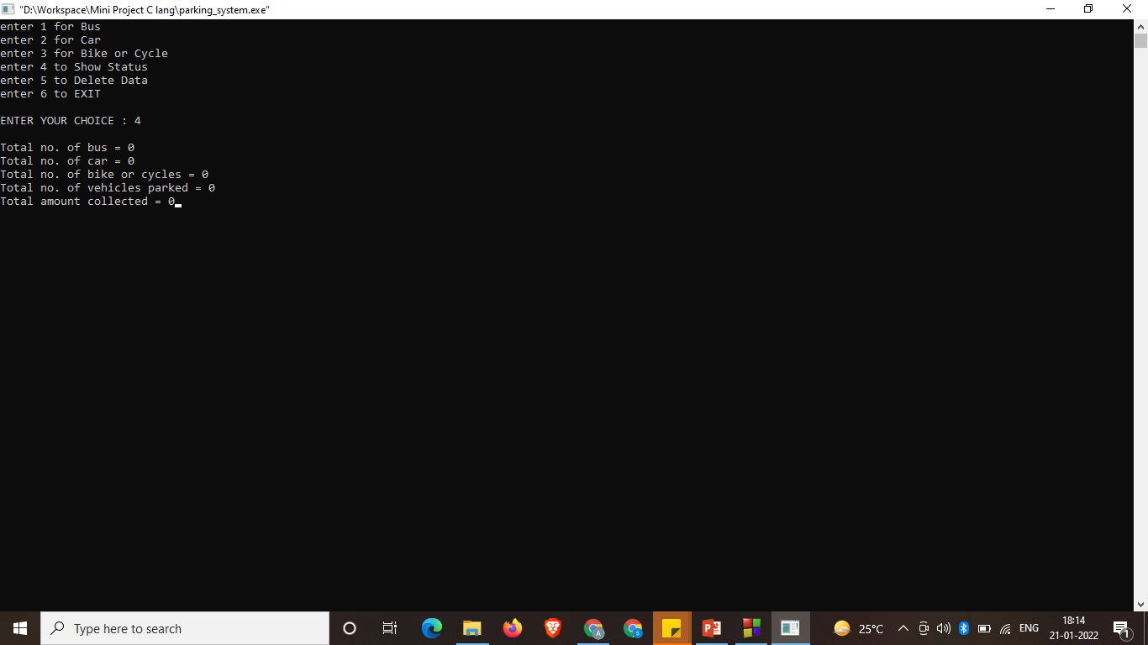

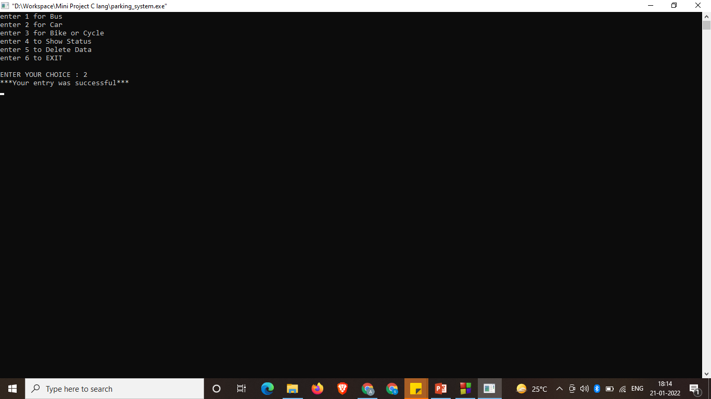

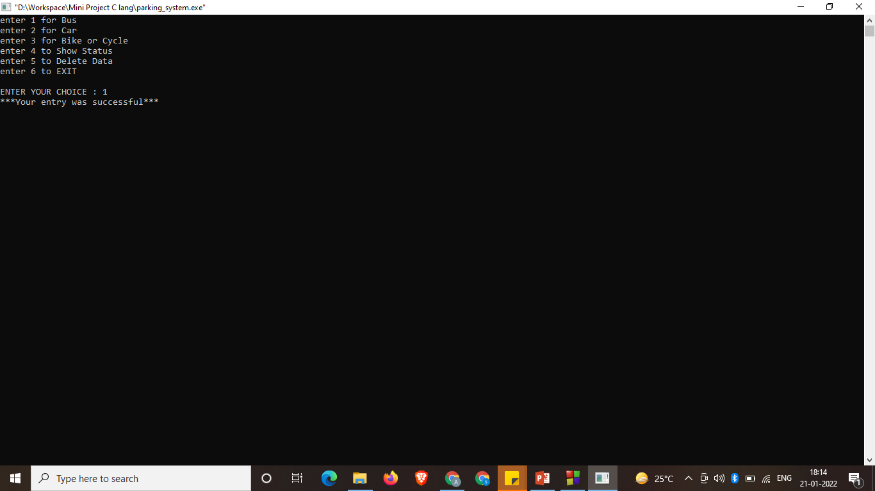

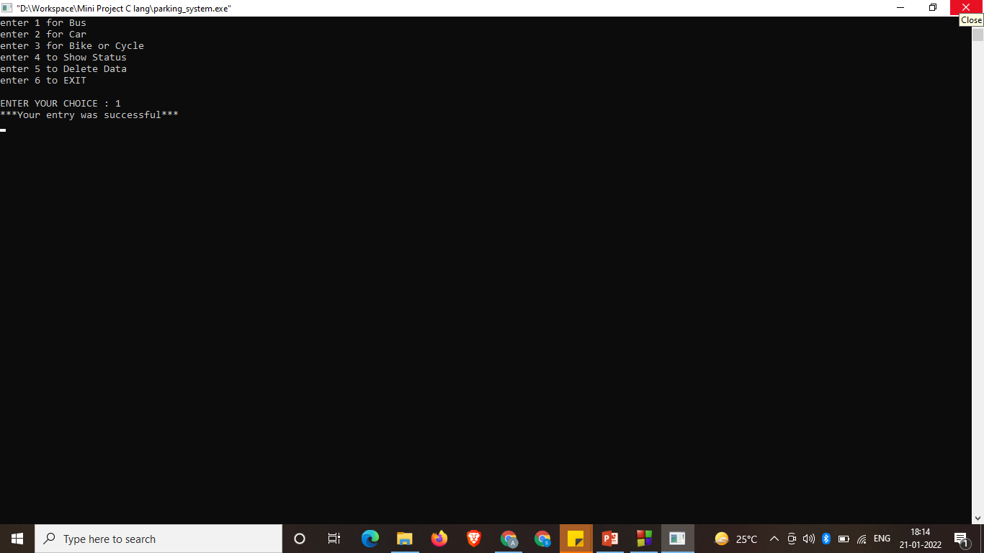

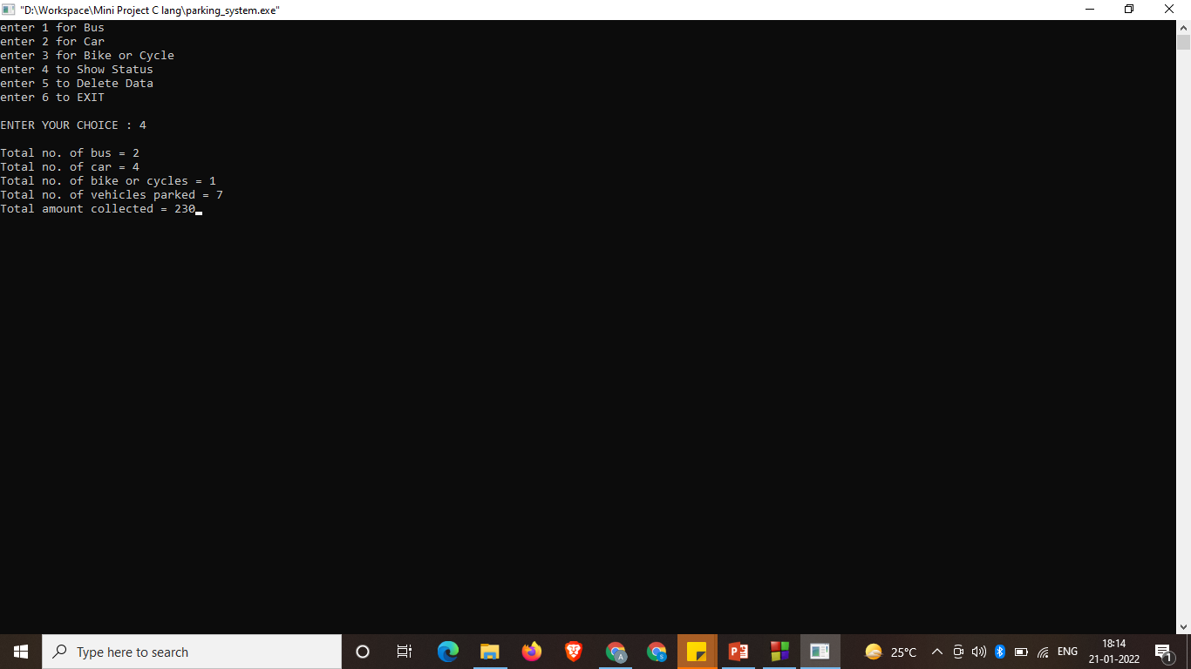

**\*\*\*THANK YOU\*\*\***